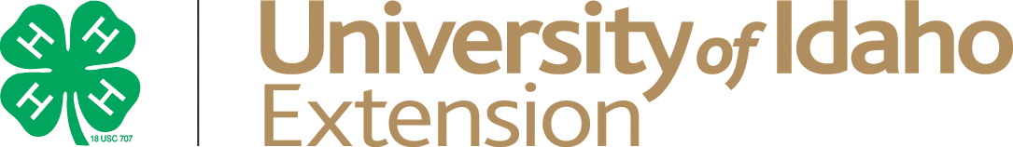

Country of Origin Labeling (COOL) Affidavit

As a producers of a market animal ultimately intended for human consumption, I understand that I am responsible to insure the animal(s) I raised are managed in a safe and wholesome manner. By offering this animal for sale, I guarantee that all applicable laws have been followed to insure a wholesome product for human use.

Member’s Name:

Address:

City: State: Zip Code:

Telephone:

Species (circle one) Beef Sheep Swine Goat Poultry Rabbit

Animal’s Ear Tag/Identification Number:

As an affidavit is deemed by USDA as an official record of Country of Origin, I attest through first-hand knowledge, normal business records, or producer affidavit(s) that this animal was born in (list country) _______________________________________ and was raised in (list country) ____________________________________.

Member’s Signature:

Parent/Guardian Signature (if member is under 18):

Date:

Business/Farm/Ranch Name:

Physical Address or Premise Number:

