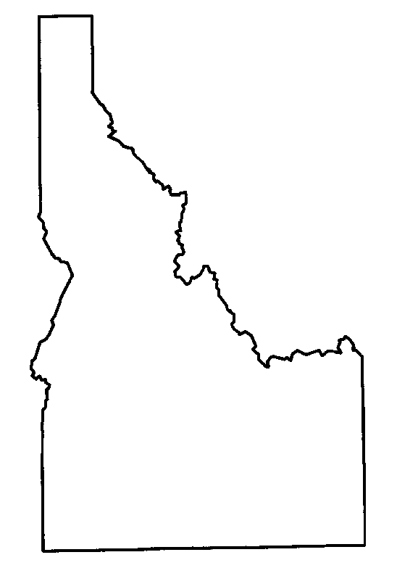
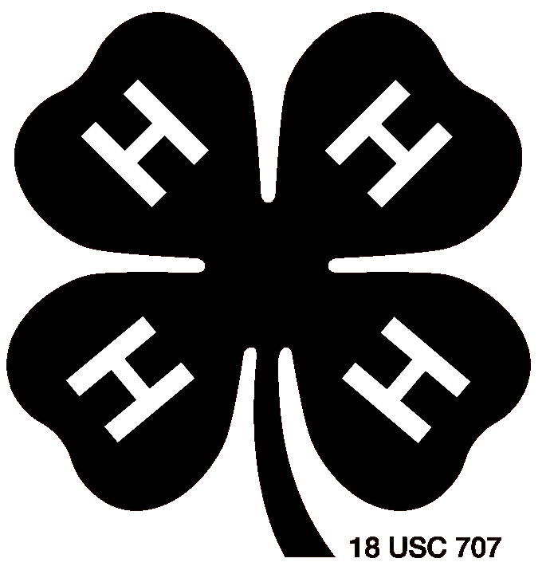

# 91910

4-H Involvement Report

Name:
County:
First Year in 4-H:

4-H Club / Project Information
Year  (Example:  2012) | 4-H Club or Project Group Name | No. of meetings
Year  (Example:  2012) | 4-H Club or Project Group Name | Held | Attended

This is an unlocked document. If you need extra pages for some sections, just copy and paste extra pages and insert as needed. This can be used as a cumulative record or an annual record, based on the requirements in your county. Check with your county Extension Office for specific instructions. However, the format should not be altered and all information to be recorded must be in Times New Roman 11 point font if completed on a computer.

Project/Club Information, continued
Year  (Example:  2012) | 4-H Club or Project Group Name | No. of meetings
Year  (Example:  2012) | 4-H Club or Project Group Name | Held | Attended

4-H Leadership
List any 4-H leadership experience(s) that you have had. Examples: Elected or appointed office held, committee chaired or served on, junior or teen leader, helping younger members, or any role(s) that involved development of leadership skills.

Year | Level* | Club/Project | What was your role? What did you do?
*Level: Local/Club (L), County (C), District (D), State (S), Regional (R), National (N).

4-H Related Community Service
List all 4-H community service activities in which you participated as a group or individually. Examples: Sharing your time by visiting a retirement home or hospital, helping with a community event, serving others, donating time or items to individuals or groups in need, and/or beautification projects.

Year | Club / Group  conducting project | Service project description.  What did you do?* | No. of Hours
Provide a brief description of what was done and for whom.

Community Service Outside 4-H
List all community service activities in which you participated as a group or individually. Examples: serving as a volunteer for a service organization, church related service activities, or school related service.

Year | Club / Group  conducting project | Service project description.  What did you do?* | No. of Hours
Provide a brief description of what was done and for whom.
4-H Contests, Activities, and Events
List any 4-H contests, activities, and events you attended or participated in that you have not already listed in your project record books. Examples: Activities (e.g., camps, field trips, clinics/workshops, exchanges, etc.); and Events (e.g., fair, show, parade), or other special events such as Know Your Government, Citizenship Washington Focus, and Teen Conference.

Year | Level* | Name of activity | Tell what you did, learned, and/or achieved
Level: Local/Club (L), County (C), District (D), State (S), Regional (R), National (N).

4-H Promotion, Awareness, and Recruitment
List all activities that you participated as a group or individually to promote 4-H. Examples: Staffing a 4-H booth at a community event, speaking to a group about 4-H, teaching others about your 4-H project, telling a friend what you like about 4-H, presentation given to promote 4-H or recruit others, news articles you wrote, radio/TV appearances.

Year | What did you do to promote your 4-H activity? * | Outcome or result of this activity **
*Provide a brief description of what was done and for whom.
**Describe new members or leaders recruited, money raised, increased awareness of 4-H, increased understanding of 4-H with elected officials, etc.

9-26-18

