Emergency Evacuation Plan for:

Unit: Integrated Research and Innovation Center (IRIC)

Unit Administrator: Russell McClanahan

Location: IRIC

Date Prepared: 1/09/17
Unit Address: IRIC, 875 Perimeter Dr. MS1122, Moscow, ID 83844-1122
Contact: Russell McClanahan
Email: russellm@uidaho.edu
Phone: 208-885-1527

Plan Overview
Introduction 3

Emergency Evacuation Procedures
General Introduction 4
To Implement an Evacuation 4
Actual Evacuation Procedures 4
Evacuation of Persons with Disabilities 5
To Alert People with Hearing Limitations 5
To Evacuate People Using Crutches, Canes, or Walkers 5
To Evacuate Wheel Chair Users Error: Reference source not found
Procedures for Lockdown (Shelter in Place) ___________________________________
Emergency Action Plan Error: Reference source not found
Fire or Explosion Emergency Procedure 7
Medical Emergency Procedure 7
Power Outage 7
IRIC Building Evacuation Procedure (including egress maps) 9
Disabled Persons Requiring Evacuation Assistance 10
Emergency Evacuation Sign-In Sheet 11

Appendix: Additional Emergency Procedures

Hazardous Materials Emergency
Hazardous Materials Emergency Procedure for Response and Mitigation
Criminal Activity or Violent Crime Emergency
Criminal Activity or Violent Crime Emergency Procedures and Reporting
Bomb Threat Procedures/Suspicious Package
- Bomb Threat Procedures
- Suspicious Package Procedures

Plan Overview

Introduction

Emergencies can occur at any time, without warning. Careful planning can help members of the University of Idaho community handle emergencies with appropriate responses. Every member of the University of Idaho community shares responsibility for emergency preparedness. Department directors and supervisors are responsible for ensuring that their units have emergency plans in place, and that all persons – including faculty, staff and students – are familiar with the emergency plans. These positions are also responsible for assigning emergency preparedness and response duties to appropriate staff members.

The IRIC Emergency Evacuation Plan is an adjunct to the University of Idaho Emergency Management Plan as is the IRIC Fire Safety Plan. Together, with plans from all required campus facilities, they provide the overall emergency response plan for the entire university. All emergency evacuation plans for critical operations must be reviewed and approved by Environmental Health & Safety.

The primary goals of the University of Idaho Emergency Evacuation Plan are:
- To protect lives, physical property, intellectual property, and minimize loss.
- To prevent or minimize the impact of emergencies and to maximize the effectiveness of the campus community in responding to occurrences.
- To provide for the continuity of campus operations in pursuit of the University of Idaho’s mission of teaching, research and extension.

Overview

Everyone in a UI facility – students, faculty, staff, and visitors – must take appropriate and deliberate action when an emergency strikes any area of the University of Idaho campus. Follow these important steps when there is an emergency:
- Confirm and evaluate conditions.
- Report the incident immediately.
- Follow instructions from emergency staff precisely.
- Issue clear and consistent emergency notifications. Use all available communication tools.
  - If power or telephone systems are not functioning, emergency communications will be profoundly restricted and the University of Idaho will use messengers, radios and cell phones.
- Coordinate with the Emergency Operations Command Center during emergencies.

Emergency Occurrence- After Hours

There is a significant chance an emergency may occur outside regular University of Idaho office hours.

While the structure of this plan remains precisely the same, the implementation may vary depending upon available resources and personnel until the proper officials can be notified. Until that time, the individuals assuming the most responsibility will be those officials/individuals of highest rank who are available. These individuals should seek to follow the guidelines of the plan as nearly as possible, while simultaneously making an effort to notify University of Idaho officials of the situation to obtain verification or advice on their actions.

Emergency Evacuation Procedures

General Introduction

A building evacuation is mandatory whenever a fire alarm sounds and building occupants should exit immediately, putting the IRIC evacuation plan into effect. After the building has been evacuated, occupants must wait for a safety inspection and recall before re-entry.

If a complete campus evacuation and closure is necessary during an emergency, it will be announced and coordinated by the University of Idaho’s leadership and Emergency Management Team.

To Implement an Evacuation

- Remain calm.
- Communicate clearly and succinctly.
  - Example: We have a ______ type of emergency. Evacuate to ______. Take only the belongings you may need for personal well-being during emergency.
- DO NOT use the elevators.
- Assist persons with disabilities or assign assistance.
- Check offices, classrooms, and restrooms; close doors, but do not lock them.
- Keep exiting groups together.
- Faculty/Instructors assist students. Take rosters.
- Gather at the designated evacuation site and await instructions.
- Account for faculty, staff and students (accountability form).

Actual Evacuation Procedures

(Evacuation is required any time the fire alarm sounds, an evacuation announcement is made or a university official orders you to evacuate.)

- Turn off equipment, if possible.
- Quickly shutdown any hazardous operations or processes and render them safe. Critical emergency coordination staff must follow the IRIC approved emergency evacuation plan. Staff members may not remain in a building once an evacuation signal or order has been given.
- Notify others in the area of the alarm if they did not hear it.
- Department heads should take staff rosters.
- Exit the building via the nearest safe exit route. Walk; do not run. Do not use elevators to exit.
- Check offices, classrooms, and restrooms; close doors, but do not lock them.
- Take jackets or other items needed for protection from the weather.
- Leave room lights on.
- If you are away from your normal working area when the alarm sounds, you should exit the building immediately and not return to your area.
- Move away from the building, report to the unit's designated evacuation point and meet with other persons from the unit or building. Report any missing or trapped people to the emergency responders.
- Keep existing groups together.
- Account for faculty, staff and students and sign in at evacuation point.
- Wait at evacuation point for directions. Do not reenter the building until emergency staff gives the "all clear" signal.

Evacuation of Persons with Disabilities

Be aware that faculty, staff and students with "hidden" disabilities (arthritis, cardiac conditions, back problems, learning disabilities, etc.) may also need individual assistance. Use the following list to inform both helpers and disabled persons. Use a "buddy system" naming who is responsible for whom.

To Assist Visually Impaired Persons
- Announce the type of emergency.
- Offer your arm for guidance.
- Tell the person where you are going and obstacles you encounter.
- When you reach safety, ask if further help is needed.

To Alert People with Hearing Limitations
- Turn lights on/off to gain the person’s attention.
- Indicate directions with gestures.
- Write a note with evacuation directions.

To Evacuate People Using Crutches, Canes, or Walkers
- Evacuate these individuals as injured persons.
- Assist and accompany to evacuation site if possible.
- Use a sturdy chair (or one with wheels) to move the person.

To Evacuate Wheel Chair Users
- Individuals at ground floor locations may exit without help.
- Individuals with movement limitations or respiratory complications must always be assisted with emergency exiting.
- Remove from smoke and vapors immediately.
- If the wheelchair is too heavy, offer lifting assistance; or try a sturdy chair. In some cases, the fire department will have to assist.
- Consult with the person to determine best carry options.
- Reunite the person with the chair as soon as it is safe to do so.

Remember that evacuated persons with disabilities must be accounted for before allowing re-entry or relocation. Persons assigned to help these individuals must provide personnel accounting following the incident.

Procedures for Lockdown (Shelter in Place)

- Report the emergency requiring lockdown (armed intruder, hazardous materials release, abduction, etc.) by calling 911, campus security 208-885-7054 (5-7054) and give the location including building name, address, and your location inside.
- Notification of the emergency will not use the fire alarm systems. VandalAlert, phone systems, email and press will provide notification.
- Account for all area/classroom, or building occupants using the attached form. Notify authorities of any discrepancies immediately.
- Recall or re-entry notifications will be given through the VandalAlert system, phone systems, email, and press releases.
- Occupants in lockdown (sheltering in place) will use the area phone systems and/or cell phones to remain in communication with authorities and campus administration during the entire event.

Emergency Action Plan

Medical Emergency Procedure

- Remain calm. Quick, decisive action will provide the best outcome for the patient.
- Protect person from further injury by removing them from the hazard. Only move injured persons when it is absolutely necessary. Alert bystanders for assistance in obtaining help.
- Immediately notify authorities of the location, nature and extent of the injury by calling 911. Always call from a safe location.
- Provide first aid until help arrives if you have appropriate training and equipment.
- Send someone outside to escort emergency responders to the appropriate location, when possible.

Fire or Explosion Emergency Procedure

When building alarm sounds, immediately begin following the evacuation procedures previously cited (page 4).

If you witness a fire or explosion:

- Alert people in the immediate area of the fire and evacuate the room.
- Confine the fire by closing doors as you leave.
- Activate the building fire alarm system by pulling the handle on a local fire alarm box.
- Notify 911 of the location and size of the fire. Always call from a safe location.
- Evacuate the building using the established Emergency Evacuation Procedure. Once outside, notify emergency responders of the location, nature and size of the fire.
- If you have been trained and it is safe, you may attempt to extinguish the fire with a portable fire extinguisher. If you have not been trained, you must evacuate the area.

Power Outage

- Assess the extent of the outage in the unit's area.
- Report the outage to the University of Idaho Facilities main desk at 208-885-6246 (5-6246) during normal operating hours. After hours call the UI Steam Plant at 208-885-6271 (5-6271).
- Assist other building occupants in moving to safe locations. Loss of power/limited power to fume hoods requires the mandatory evacuation of laboratories and surrounding areas.
- Implement the unit's power outage plan. Evaluate the unit's work areas for hazards created by power outage. Secure hazardous materials. Take actions to preserve human and animal safety and health. Take actions to preserve research.
- Turn off and/or unplug non-essential electrical equipment, computer equipment and appliances. Keep refrigerators and freezers closed throughout the outage to help keep them cold.
- If needed, open windows (in mild weather) for additional light and ventilation.
- To obtain information about a prolonged outage, you may call the AVISTA hotline at 800-221-9187 or visit: https://www.avistautilities.com/safety/outages/pages/default.aspx

Remember that these plans are a guide and are unable to outline or determine every event encountered in an emergency. UI is intent on maintaining your safety while on campus. If you feel endangered or threatened, please take adequate measures to protect yourself and notify authorities of the situation.

IRIC Building Emergency Evacuation
Procedure
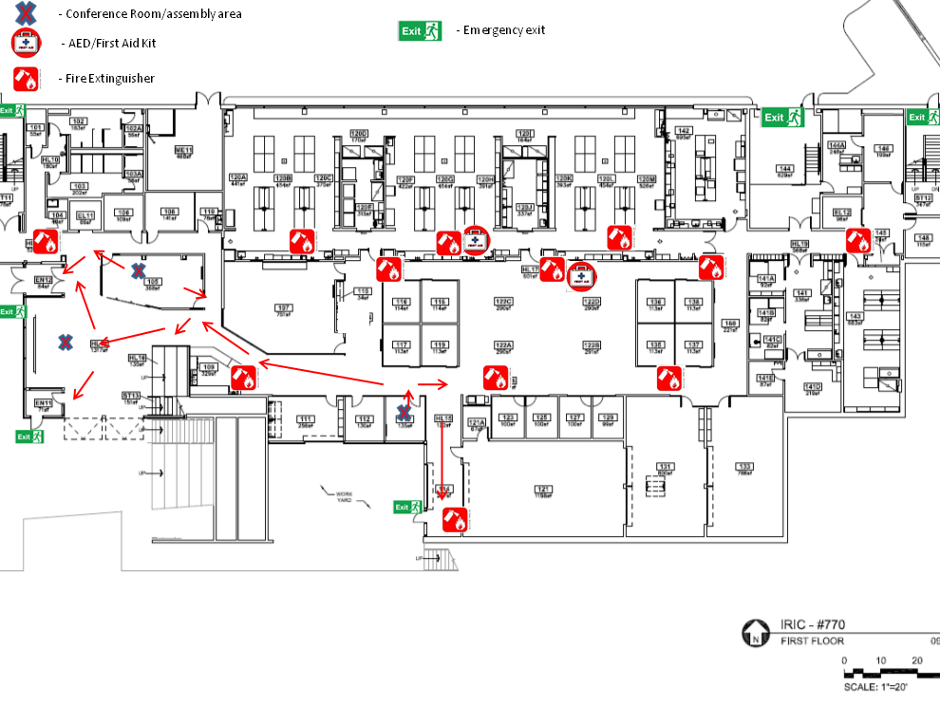

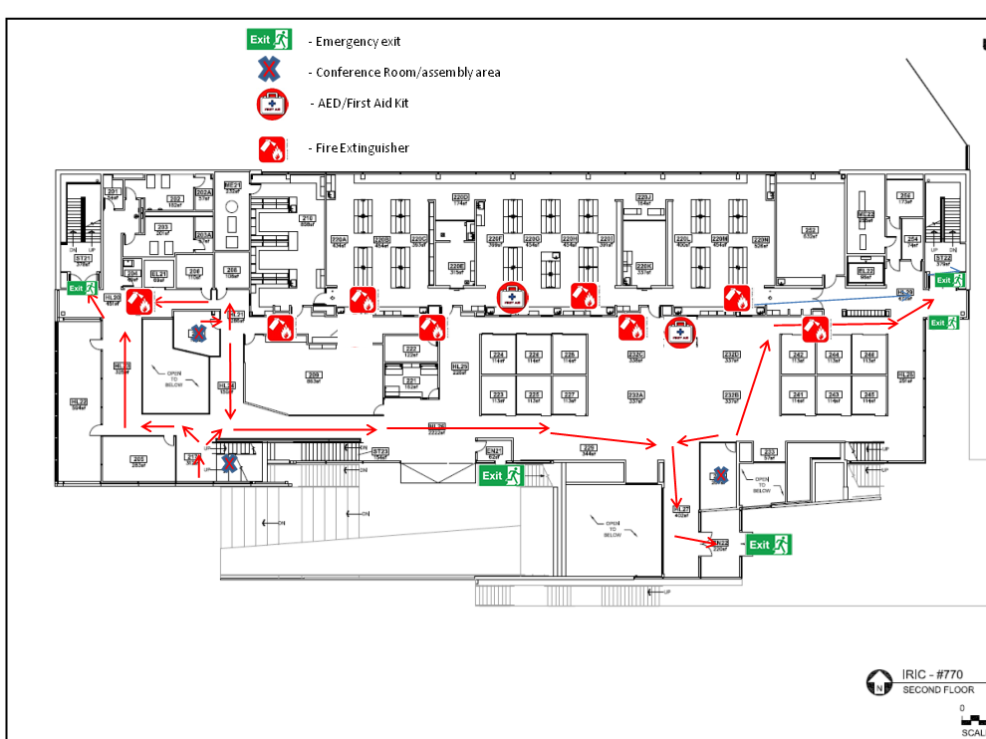

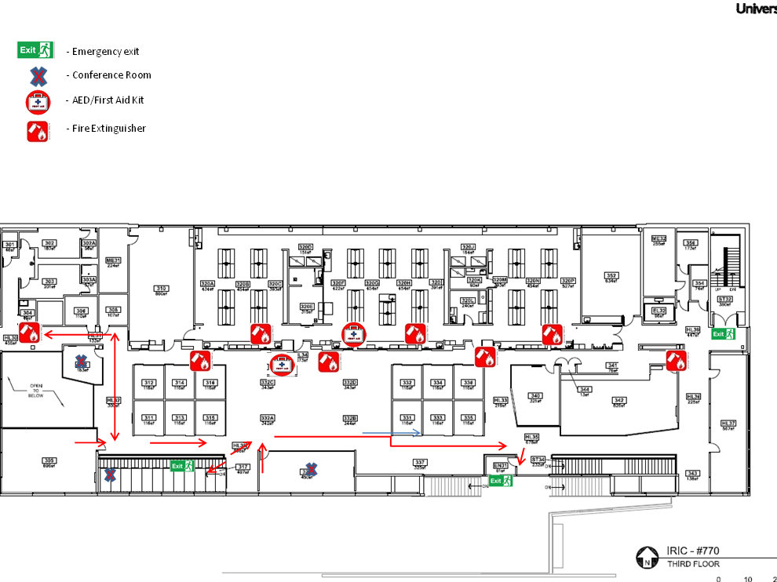

IRIC Building Evacuation Procedure

The need to account for and mobilize the IRIC staff in an orderly way is crucial to an effective response in emergency evacuation situations.

When a fire drill sounds in one of the IRIC facilities – all staff (including student staff on duty) in the building must go to one of the two pre-determined rendezvous points below.
- Across academic mall from IRIC- between Renfrew Hall and Agricultural Science Bldg.
- On Line Street – Behind Brink Hall (do not cross Line Street)

As you are leaving the building:
- We have collective responsibility for making sure that everyone gets out, as we are getting out quickly ourselves.
- If you are a member of a buddy system please move quickly to help your buddy exit the building safely.
- On the way out, knock on your neighbors' doors, intrude into meetings, make sure that student staff get out of the building. It is not practical to assign this responsibility to any one person or even a small group, since there is just no way to guarantee who will actually be in a building at any time of the day or night.
- If possible, practical, and safe – bring your personal belongings like coats, backpacks, handbags, wallets, etc.

When you arrive at the designated rendezvous site you will need to sign in:
- If pre-designated members of the Emergency Response Team are present, one or more of them will have sign-in forms and you will be asked to sign in.
- If pre-designated members of the Emergency Response Team are not present, then at least one staff member present should assume responsibility for creating a sign-in sheet and obtaining all signatures (including student staff).
Appendix: Additional Emergency Procedures

Hazardous Materials Emergency Procedure

A Hazardous Materials Emergency exists when:
- Cleanup of a spill of a hazardous material is beyond the level of knowledge, training or ability of the staff in the immediate spill area, or
- The spill creates a situation that is immediately dangerous to the life and health of persons in the spill area or facility.

Environmental Health and Safety is equipped to respond to and clean up Hazardous Material Spills.
- Alert people in the immediate area of the spill and evacuate the room. Confine the hazard by closing doors as you leave the room.
- If personnel have contacted the material, use the eyewash or safety showers. Isolate contaminated individuals.
- Evacuate any nearby rooms that may be affected. If the hazard will affect the entire building, evacuate the entire building.
- If there is a chance of explosion from the chemical spill do not activate the building fire alarm. Evacuate the building manually by alerting others by voice. Take care not to turn electrical equipment on or off or otherwise cause sparks. If there is no chance of explosion, activate the building fire alarm system by pulling the handle on a local fire alarm box.
- Notify emergency services of the chemical, location and size of the spill by calling 911. Always call from a safe location. Be prepared to spell chemical names.
- If building evacuation is required, evacuate the building using the Emergency Evacuation Procedure presented in this guide. Once outside, notify emergency responders of the location, nature and size of the spill.

Criminal Activity or Violence Emergency Procedure
- Attempt to remove yourself from any danger.
- Notify Police by calling 911. Try to call from a safe location if possible.

If possible, provide the police with the following information:

- Location of crime
- Nature of crime and specifics (number of people involved, any weapons, etc.)
- Any injuries
- Description of suspect(s) (height, weight, sex, race, clothing, hair color etc.)
- Direction of travel of suspects
- Description of any vehicles involved in the crime
- DO NOT pursue or attempt to detain suspects.

Bomb Threat Procedure

Remain calm and obtain as much information as possible from the caller. Try to write down the caller's exact words. Ask for and try to obtain the following information:

- When is the bomb going to explode?
- Where is the bomb located right now?
- What does the bomb look like?
- What kind of bomb is it?
- What will cause the bomb to explode?
- Did you place the bomb?
- Why?
- What is your address?
- What is your name?
- Also record the following information:
- Exact time the call is received
- Information about caller including:

- Gender
- Education
- Age
- Background noise
- Location of caller
- Accent
- Speech impediments or traits
- Caller's attitude

Immediately notify police by calling 911. Always call from a safe location. Provide the police with the context of the threat, telephone number on which it was received, your name, room number and telephone number where you can be reached. Take no other action unless directed to by the Police.

Suspicious Package Procedure

If you receive or observe a suspicious letter or package that is unexpected or unknown with the following characteristics:

- Excessive postage
- Misspellings of common words
- Excessive weight
- Rigid envelope
- Handwritten or poorly typed address
- Restrictive markings such as confidential, personal, etc.
- An excessive amount of securing material used, such as masking tape, string, etc.
- Incorrect titles
- Oily stains or discoloration
- Visual distractions
- Lop-sided or uneven
- No return address
- Protruding wires or tinfoil

Immediately:
- Notify the Police immediately by calling 911. Always call from a safe location.
- Move people away from the package.
- DO NOT move or open the package.
- DO NOT investigate too closely.
- DO NOT cover, insulate or place the package into a cabinet or drawer.

Remember that these plans are a guide, and are unable to outline or determine every event encountered in an emergency. UI is intent on maintaining your safety while on campus. If you feel endangered or threatened, please take adequate measures to protect yourself and notify authorities of the situation.

